Задание

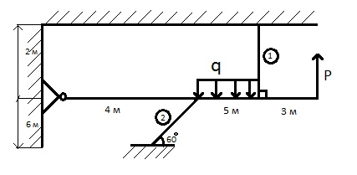
$$\begin{aligned}P=\text{50} \text{kH} \\ q=\text{10}\frac{\text{kH}}{м} \\ Е_{1,2}=2⋅{\text{10}}^{6} \frac{\text{кГ}}{{\text{см}}^{2}} \\ \frac{F_{1}}{F_{2}}=1 \\ \left[σ\right]=\text{1800} \frac{\text{кГ}}{{\text{см}}^{2}} \\ N_{1};N_{2}=?\end{aligned}$$

